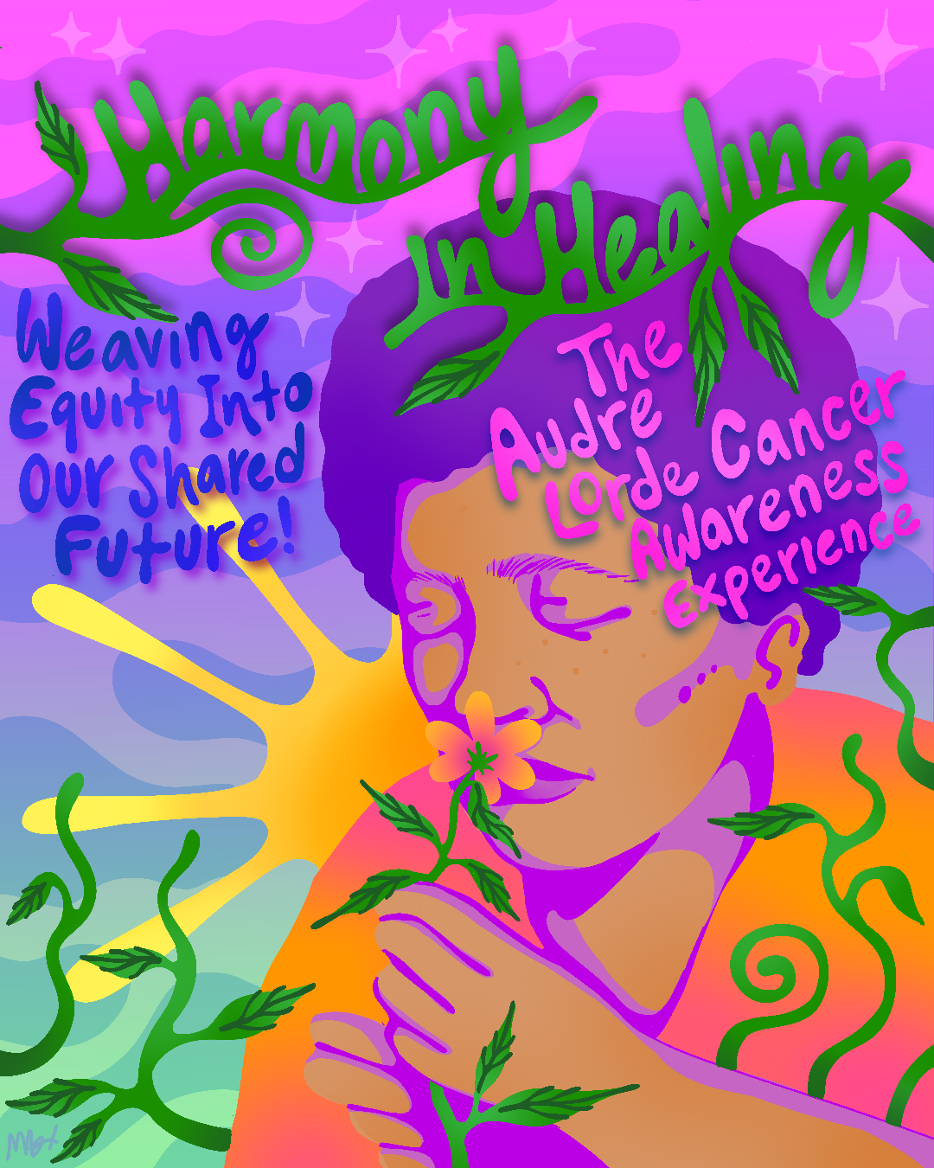

Resource Guide 2024

3
Table of Contents

Foreword | 3
Community in the Fight Against Cancer | 5
Black, Indigenous, and other People of Color (BIPOC) | 5
Women  LGBTQIA+ People | 9  11
Cancer Screenings: What Screenings Do You Need? | 12
How to Stay Healthy | 13
Resources for Patients | 15
Patient Navigation and Cancer Care Services
Support Groups
Financial Assistance
Nutrition and Fitness
Tobacco Cessation Programs

Foreword

Started in 1999, Denise Bentley, a former Fenway Health employee, founded the event in honor of her late wife Lorraine “Faye” Fayette Johnson. She created a space to honor two warrior women who battled breast cancer: her wife and Audre Lorde, a self-described “Black, lesbian, mother, warrior, poet” who dedicated her life to addressing the injustices of racism, sexism, and homophobia. Denise recognized that cancer uniquely affects women of color and the LGBTQIA+ community and established a venue to discuss these health disparities, build community, and celebrate life.

Intersectionality, a term coined by Kimberlé Crenshaw (1989), is a critical framework for understanding how various social identities such as race, gender, and sexual orientation intersect to create unique experiences of oppression and privilege (Collins & Bilge, 2020). In the context of cancer health disparities, intersectionality helps to illuminate how individuals who are BIPOC (Black, Indigenous, and People of Color), women, and/or LGBTQIA+ face compounded challenges in accessing healthcare, receiving equitable treatment, and achieving positive health outcomes (Bowleg, 2012; Williams et al., 2019).

Audre Lorde, a Black lesbian feminist and cancer survivor, provides a poignant example of how intersectionality plays a role in cancer health disparities (Lorde, 1980).

- Racial Disparities: Lorde's experiences as a Black woman navigating the healthcare system underscore the racial biases that can affect diagnosis, treatment, and care (Lorde, 1980; Wailoo, 2011). BIPOC individuals often face systemic racism that can lead to delayed diagnoses and inadequate treatment options (Smedley et al., 2003; Institute of Medicine, 2003).
- Gender and Sexual Orientation: As a woman and a member of the LGBTQIA+ community, Lorde's narrative also sheds light on the gendered and heteronormative assumptions within medical practices (Lorde, 1988; Jain, 2013). Women, particularly those who identify as LGBTQIA+, may encounter healthcare providers who lack understanding or sensitivity to their specific needs, leading to disparities in care (Quinn et al., 2015; Kamen et al., 2015).
- Economic and Social Barriers: Lorde's reflections also touch on the economic and social barriers that intersect with race, gender, and sexual orientation (Lorde, 1980; Lorde, 1988). These barriers can include lack of access to health insurance, financial constraints, and social stigmatization, all of which can exacerbate health disparities (Adler & Newman, 2002; Williams & Mohammed, 2009).

Through her writings, Audre Lorde emphasizes the importance of recognizing and addressing these intersecting identities to improve health outcomes and achieve equity in cancer care (Lorde, 1980; Lorde, 1988). Her work calls for a more inclusive and comprehensive approach to healthcare that acknowledges and addresses the diverse experiences of marginalized communities (King, 1988; Crenshaw, 1991).

The cancer awareness experience serves as a space to encourage people living with cancer, survivors, caregivers, allies, and supporters, to unite in solidarity, and practice self-care, healing, and racial and social justice.

Sources:
- Adler, N. E., & Newman, K. (2002). Socioeconomic disparities in health: Pathways and policies. Health Affairs, 21(2), 60-76.

- Bowleg, L. (2012). The problem with the phrase women and minorities: Intersectionality—an important theoretical framework for public health. American Journal of Public Health, 102(7), 1267-1273.

- Collins, P. H., & Bilge, S. (2020). Intersectionality. Polity Press.

- Crenshaw, K. (1989). Demarginalizing the intersection of race and sex: A Black feminist critique of antidiscrimination doctrine, feminist theory, and antiracist politics. University of Chicago Legal Forum, 1989(1), 139-167.

- Crenshaw, K. (1991). Mapping the margins: Intersectionality, identity politics, and violence against women of color. Stanford Law Review, 43(6), 1241-1299.
- Institute of Medicine. (2003). Unequal treatment: Confronting racial and ethnic disparities in health care. National Academies Press.

- Jain, S. L. (2013). Malignant: How cancer becomes us. University of California Press.

- Kamen, C., Smith-Stoner, M., Heckler, C. E., Flannery, M., & Margolies, L. (2015). Social support, self-rated health, and lesbian, gay, bisexual, and transgender identity disclosure to cancer care providers. Oncology Nursing Forum, 42(1), 44-51.

- King, D. K. (1988). Multiple jeopardy, multiple consciousness: The context of a Black feminist ideology. Signs: Journal of Women in Culture and Society, 14(1), 42-72.

- Lorde, A. (1980). The cancer journals. Aunt Lute Books.

- Lorde, A. (1988). A burst of light: Essays. Firebrand Books.

- Quinn, G. P., Sanchez, J. A., Sutton, S. K., Vadaparampil, S. T., Nguyen, G. T., Green, B. L., & Kanetsky, P. A. (2015). Cancer and lesbian, gay, bisexual, transgender/transsexual, and queer/questioning (LGBTQ) populations. CA: A Cancer Journal for Clinicians, 65(5), 384-400.

- Smedley, B. D., Stith, A. Y., & Nelson, A. R. (Eds.). (2003). Unequal treatment: Confronting racial and ethnic disparities in health care.
- National Academies Press.

- Wailoo, K. (2011). How cancer crossed the color line. Oxford University Press.

- Williams, D. R., & Mohammed, S. A. (2009). Discrimination and racial disparities in health: Evidence and needed research. Journal of
- Behavioral Medicine, 32(1), 20-47.

- Williams, D. R., Lawrence, J. A., & Davis, B. A. (2019). Racism and health: Evidence and needed research. Annual Review of Public Health, 40, 105-125.

Solidarity in the Fight Against Cancer: Health Risks and Disparities for individuals who are BIPOC, Women, and LGBTQIA+

When accessing healthcare, individuals who are BIPOC, women, and the LGBTQIA+ community face social and economic barriers as a result of racism, sexism, and homophobia. These factors, or social determinants of health, include limited access to resources, such as education, employment, housing, health care services, and food. Historical barriers to these resources negatively affect the health outcomes of people of color and LGBTQIA+ women in the fight against cancer. Striving to overcome these health disparities also brings our communities together. This section will explore the health risks and disparities faced by people of color and LGBTQIA+ women.

Individuals who are BIPOC
Cancer is the overall leading cause of death among Boston residents, regardless of race and ethnicity. Below we explore how cancer has affected individuals who are BIPOC in Boston, specifically Latiné, Asian, and Black individuals, over the past 20 years. These outcomes highlight the progress as well as pervasive social, economic, and systemic barriers individuals who are BIPOC.

“These outcomes highlight the progress as well as pervasive social, economic, and systemic barriers for individuals who are BIPOC.”

Breast Cancer
Despite similar screening rates, breast cancer deaths are disproportionately high among women of color. Between 1999 and 2013, the death rates for
Latinas and White women Boston residents have decreased. However, the incidence of breast cancer for Asian women has increased by 89%. Deaths among Black women under 65 is higher than those of White women. Today, women of color are still more likely to die at an earlier age from breast cancer.
Also, Black and White women have similar rates of breast cancer diagnosis, but Black women are
more likely to die from the disease.

Rate of Death from Breast Cancer by Race/Ethnicity
Black women are more likely to die from breast cancer despite having high screening rates.

Black 31.1

White 24.8

Latina 10.3
Asian 6.4

Race/Ethnicity
Asian | 62%
Black | 86%
Latino | 84%
White | 92%

Cervical Cancer
Cervical Cancer Screenings by Race/Ethnicity

Cervical cancer screening rates are generally high across Boston, but they are much lower among Asian women. In 2013, 92% of White women reported having a pap smear, compared to 62% of Asian women in Boston. Today, Asian women are almost 20% less likely than Black and Latina women to receive cervical cancer screenings. These disparities for Asian women can, in part, be attributed to cultural, social and economic factors, such as the amount of time lived in the U.S., citizenship status, English language skills, and income. These factors affect the community’s access to preventive care.

Colon Cancer
In the city of Boston, colon cancer is the third leading cancer- related cause of death for men and women. Between 1999 and 2013, the number of diagnoses

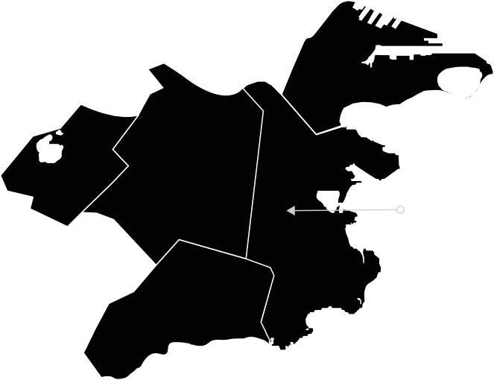
remained the same for Latiné residents and decreased for White, Asian, and Black residents. Today, colon cancer deaths are the highest in neighborhoods of color, specifically, North Dorchester,
Top Five Boston Neighborhoods with the Highest Prostate Cancer Mortality Rates per 100,000 Population

South Boston 17.9

Jamaica Roxbury
Plain 49.5
31.2 Dorchester
N. Dorchester: 29.8
S. Dorchester: 17.9

Mattapan
75.4

prostate cancer incidence and mortality rates decreased across all races and ethnicities. But Black men are still more likely to be diagnosed and die from prostate cancer than any other racial and
Lung Cancer
In Boston, lung cancer is the leading cause of cancer-related deaths for all residents, regardless of race, ethnicity, and sex. From 1999 to 2013, the lung cancer incidence rate decreased among Black and White residents.
Latiné residents had the lowest lung cancer mortality rates, yet they were the only group to experience an increase in deaths. Today, although white individuals have the highest rates of lung cancer in Boston, the highest mortality rates occur in Mattapan, a predominantly African American community, at almost twice the city’s average lung cancer death rate. This is a prime example of social determinants of health serving as barriers to care.

Sources

Race/Ethnicity
Latino | 23%
Asian | -8%
White | -22%
Black | -28%

Only Latiné individuals experienced an increase in deaths from lung cancer over time.
Lung Cancer Mortality by Race/Ethnicity, 1999-2013

Roxbury, South Dorchester and the South End. This can be attributed, in part, to lack of access to
quality food, physical activity in a safe environment, and access to comprehensive preventive health care in these neighborhoods.

Prostate Cancer
Prostate cancer is the second leading cause of cancer-related deaths among male residents in Boston. Between 1999 and 2013,
ethnic group. Today, neighborhoods of color, such as Roxbury and Mattapan, experience the highest rates of deaths caused by prostate cancer, at almost
two and three times the rate of Boston. Latino men in Boston are one and a half times more likely to face prostate cancer compared to White men, while Asian men have a lower rate.
- “2016 Community Health Needs Assessment.” Dana-Farber Cancer Institute. http://www.dana-farber.org/ uploadedFiles/Library/about-us/community-outreach/chna-report-2016.pdf.
- Gomez, Scarlett G. et al. “Disparities in Mammographic Screening for Asian Women in California: A
- Cross-Sectional Analysis to Identify Meaningful Groups for Targeted Intervention.” BMC Cancer 7 (2007): 201. PMC.
- Wang, Judy H. et al. “Disparities in Cervical Cancer Screening between Asian American and Non-Hispanic White Women.” Cancer Epidemiology Biomarkers and Prevention 17.8 (2008). 1968-1973.
- “Health of Boston Special Report: Cancer Among City of Boston Residents 1999-2013.” Boston Public Health Commission.http://www.bphc.org/healthdata/health-of-boston-report/Documents/BPHC_HOB_CancerRe- port2018_V3[1].pdf.

Women

Cancer significantly impacts women in the United States, with breast cancer being a major concern. In 2024, it is estimated that there will be 310,720 new cases of breast cancer among women, accounting for 15.5% of all new cancer cases, and 42,250 deaths, representing 6.9% of all cancer deaths.

Cancer morbidity and mortality disparities among women with marginalized identities in the United States are significant and multifaceted. Women from marginalized groups, including those defined by race, ethnicity, gender identity, and socioeconomic status, often experience worse outcomes in terms of cancer incidence, treatment access, and survival rates.

For example, Black women have a 40% higher mortality rate from breast cancer compared to White women, despite having a slightly lower incidence rate of the disease. This disparity is indicative of broader systemic issues, including differences in access to quality healthcare and treatment options.

In the context of ovarian cancer, disparities in survival, stage at diagnosis, and treatment have been documented among various racial, ethnic, and socioeconomic groups. Moreover, women with marginalized identities, such as those who are currently incarcerated or experiencing homelessness, have not been adequately studied, leaving gaps in understanding their specific cancer-related challenges.

Overall, the evidence suggests that social, environmental, and economic disadvantages contribute to the disproportionate burden of cancer morbidity and mortality among these populations. Information is missing on specific statistics or studies focusing on the intersection of cancer disparities and marginalized identities beyond those mentioned.

LGBTQIA+ Women
LGBTQIA+ women face their own unique challenges and health disparities with regard to cancer. Unfortunately, cancer research has not included uniform data collection regarding sexual orientation and gender identity. This lack of research creates a gap in understanding the effects of cancer on LGBTQIA+ communities. However, researchers and activists in the community are starting to make strides in analyzing the communities’ cancer health risks and barriers to care.

Barriers to Healthcare
The LGBTQIA+ community faces barriers to healthcare that contribute to lower cancer screening rates and therefore higher risks of late stage cancer diagnosis than the general population.

Health Risk Factors
Gender identity and sexual orientation discrimination as well as limited social and economic resources, such as health insurance, create barriers for LGBTQIA+ individuals seeking cancer screenings and treatment. In response to these stressors, lesbian and bisexual women may engage in coping strategies (for example, smoking, binge eating, or alcohol/drug use) that have health risks, including cervical, colon, lung, and uterine cancer.
In addition, lesbian and bisexual women are more likely than heterosexual women to delay childbirth until after age 30, or to not have biological children at all, which increases the risk of breast, ovarian, and uterine cancer.
1 in 5 transgender patients has been turned away by a health care provider.

Transgender Women
Within the LGBTQIA+ community, transgender women face the most profound barriers to both social and economic resources, which may lead to higher rates of cancer and cancer deaths. These barriers include:
- Lack of access to affirming care
- 1 in 5 transgender patients has been turned away by a health care provider
- Lowest insurance rates among LGBTQIA+ communities
- Procedures or cancer screenings that are inconsistent with the gender marked on the insurance card are rarely covered by insurance, such as a prostate exam for a transgender woman
- High rates of smoking & alcohol use

Sources
- National LGBT Cancer Network: http://cancer-network.org
- The National LGBT Cancer Project: http://lgbtcancer.org
- Cancer Care LGBT Resources: https://cancercare.org/tagged/lgb
“LGBT Cancer Information.” Cancer Network. https://cancer-network.org/cancer-information
- “New Report Reveals Rampant Discrimination against Transgender People by Health Providers, High HIV Rates and Widespread Lack of Access to Necessary Care.” National LGBTQIA+ Task Force. http://www.thetaskforce.org/new-report-reveals-rampant-discrimination-against-trans- gender-people-by-health-providers-high-hiv-rates-and-widespread-lack-of-access-to-neces- sary-care-2

LGBTQIA+ People

The impact of cancer on LGBTQIA+ individuals in the United States is significant, characterized by higher incidence rates, unique healthcare disparities, and varying mortality outcomes.

Research indicates that LGBTQIA+ populations may experience a higher risk of certain cancers compared to heterosexual and cisgender individuals. For instance, gay and bisexual men have higher rates of anal, prostate, testicular, and colon cancers, while lesbian and bisexual women face increased risks for breast and cervical cancers, often linked to lower screening rates and misconceptions about HPV transmission.

Healthcare disparities contribute to these elevated risks. Factors such as discrimination, lack of cultural responsiveness among healthcare providers, and inadequate insurance coverage create barriers to accessing timely and appropriate cancer care. These barriers can lead to delayed diagnoses and treatment, exacerbating health outcomes for LGBTQIA+ individuals.

The absence of comprehensive data collection on sexual orientation and gender identity in national health surveys limits the understanding of cancer incidence and prevalence within this community.

LGBTQIA+ individuals often face worse health outcomes compared to their non-LGBTQIA+ peers, highlighting the need for targeted public health initiatives and improved healthcare access.

Cancer Screenings:
What Screenings Do You Need?

Cancer screenings are medical tests used to look for cancer before the development of symptoms. These procedures can save lives by detecting cancer early, allowing for treatment to begin when the disease is easier to treat. These screenings are especially important for women of color and LGBTQIA+ women who face health disparities concerning cancer. The table below specifies the age to begin and frequency at which to get cancer screenings.

Please note that these screening recommendations are for individuals at average risk for each of these cancers. Advocate for yourself by talking to your provider about your risks and the right screening approach for you.

Insurance coverage: Contact your insurance company to discuss cover- age. If you are not insured, contact your local community health center to enroll.

Rule of thumb: If you have the organ and fall into the age categories, get screened!

Cancer | Screening | Age | Frequency of Screening
Breast Cancer | Mammography | 40–74 years old* | Every 1-2 years
Cervical Cancer | Pap Test or HPV Test | 21–65 years old | Every 3 or 5 years
Colon Cancer | Multiple Screening Options | 45–75 years old | Every 1, 3 or 10 years
Lung Cancer | Low-Dose CT | For smokers and ex-smokers 50-80 years old | Discuss with provider
Prostate Cancer | PSA Blood Test | Discuss with provider | Discuss with provider
* Individuals between the ages 40–49 can start to ask their doctors about mammograms.
Sources
U.S. Preventative Services Task Force. https://www.uspreventiveservicestaskforce.org

“2016 Community Health Needs Assessment.” Dana-Farber Cancer Institute. http://www.dana-farber.org/ uploadedFiles/Library/about-us/community-outreach/chna-report-2016.pdf

How to Stay Healthy
In addition to following cancer screening guidelines, you can reduce your risk of cancer by making healthy choices. Here are some tips and resources to help you get started.


Eat a healthy diet
Focus on increasing fruits, vegetables, and whole grains. Limit intake of salt, sugar, and processed and red meat. Check out the nutrition and fitness resources on page 20 for accessible, affordable services.

Get active
Engage in 150 minutes of moderate intensity activity each week, such as yoga, walking, softball, and water aerobics. You can also engage in 75 minutes of vigorous intensity activity each week, such as jogging or running, basketball, hiking, and biking. Make exercise fun by involv- ing friends or family, playing music, understanding your body’s limits, and scheduling time for exercise. Check out the nutrition and fitness resources on page 20 for accessible, affordable services.
Stay away from tobacco
Smoking can cause cancer and other health risks. Quitting smoking and tobacco use can be hard. Check out the tobacco cessation re- sources on page 21 to access local, judgment-free tobacco cessation programs to help you quit smoking.
Limit alcohol
Drink no more than 1-2 drinks per day. If you are struggling with al- cohol use, contact your local community health center or talk to your provider for referrals to addiction recovery services.
Use sunscreen with SPF 30 or more
Sunscreen provides a level of protection against the sun by absorbing or blocking its damaging ultraviolet rays. People of color are still at risk for skin cancer and are not as rapidly diagnosed, which leads to more deaths. Check out the article “The Best Sunscreen for Women of Color” by Teen Vogue for affordable sunscreen options.
Sources
“Stay Healthy.” American Cancer Society. https://www.cancer.org/healthy.html.
“The Best Sunscreen for Women of Color.” Teen Vogue. http://www.teenvogue.com/story/best-sunscreen- for-women-of-color-spf-misconceptions.

Resources for Cancer Survivors and Patients of Color

Patient Navigation and Cancer Care Services
Patient navigators provide advocacy and case management to cancer patients who face barriers to care. They meet with patients to link them to a broad range of services, including insurance, interpreter services, transportation, financial assistance, and other community resources.

Breast Health Program,
Mattapan Community Health Center Mattapan
The Breast Health Program provides mammograms, referrals for patients, and case management.

Cancer Care Center, Boston Medical Center The South End

PHONE
617.322.8037

WEBSITE
mattapanchc.org/services/mammography

PHONE
617.638.64

Asian Women for Health

A peer-led, community-based network that provides breast and cervical health education and peer support leaders who speak various Asian languages.

AstraZeneca Hope Lodge Center Jamaica Plain
This state-of-the-art facility serves as
a “home away from home” for patients traveling 40+ miles to their outpatient treatments. There is no charge to stay at Hope Lodge for patients or caregivers.

Breast Health Outreach Program, Codman Square Health Center
Dorchester
The Breast Health Outreach Program at Codman Square Health Center features screenings, education, and outreach around breast health.

PHONE
617.767.1071

WEBSITE
asianwomenforhealth.org

PHONE
800.227.2345

WEBSITE
cancer.org/support-programs-and-services/patient-lodging/hope-lodge/boston.html

PHONE
617.822.8147

WEBSITE
codman.org/services/radiology.html

Boston Medical Center offers support groups, fitness and nutrition classes, community events, acupuncture, interpreter services, and patient navigation.

Cancer Center,
Beth Israel Deaconess Medical Center Longwood Medical Center
The Cancer Center at BIDMC provides an online community, interpreter services in
+30 languages, support groups, Chinese- speaking patient navigator, nutrition therapy, and more.

Community Cancer Center, Whittier Health Center
Roxbury
The center is a partnership between Whittier Health Center and Dana-Farber Cancer Institute. The partnership features coordination of care, tobacco cessation, social work support, interpreter services, and cancer education and screenings.
WEBSITE
bmc.org/cancer

PHONE
617.667.1900

WEBSITE
bidmc.org/centers-and-departments/cancer-center

PHONE
617.989.3183

WEBSITE
wshc.org/programs/cancer- survivorship-primary-care-clinic/

Dana-Farber Cancer Institute Longwood Medical Center  Dana-Farber Cancer Institute offers nutrition services, support groups, a sexual health program, fitness classes, financial counselors and patient navigators, LGBTQIA+ patient support, language interpreters, disability services, | PHONE  617.632.3000  WEBSITE  dana-farber.org |  | Chinese Cancer Survivor and Family Support Group, Boston Chinese Evangelical Church  This group provides resources and support for the community on the third Saturday 2-4pm. | CONTACT  Joan Kwok
EMAIL
kwok410@gmail.com
and more.  Facing Cancer Together Multiple Locations  Facing Cancer Together provides free support groups for individuals  with cancer, bereavement, caregivers, multicultural groups, writing, and other wellness programming. | PHONE  617.332.5777  WEBSITE  facing-cancer.org |  | Portuguese-Speaking Support Group, Facing Cancer Together and Brazilian American Center (BRACE)  Open to Portuguese speaking individuals who have experienced cancer and their caregivers. The meeting is held at the Brazilian American Center in Framingham every Tuesday from  6:30-8:30 p.m. | CONTACT  Paulo Torrens
PHONE
857.389.3738
EMAIL
ptorrens@facing-cancer.org
Massachusetts General Hospital Cancer Center  Beacon Hill  The Cancer Center at MGH offers fitness classes, support groups, nutrition counseling, educational workshops, and social workers. | PHONE  617.726.5130  WEBSITE  massgeneral.org/cancer |  | Portuguese-Speaking Support Group, Facing Cancer Together and Brazilian American Center (BRACE)  Open to Portuguese speaking individuals who have experienced cancer and their caregivers. The meeting is held at the Brazilian American Center in Framingham every Tuesday from  6:30-8:30 p.m.  Spanish-Speaking Support Group, Boston Medical Center  Open to Latina/o individuals who have experienced cancer and their supporters. Dinner, parking validation, and assistance with transportation home are provided. The meeting is held 5-7pm on the last Tuesday of the  month at Boston Medical Center in the Moakley 3rd Floor Conference Room.
PHONE
617.638.7540
EMAIL
cancersupport@bmc.org
Support Groups  All of the support groups are free. To | register, please contact the names |  | Spanish-Speaking Support Group, Boston Medical Center  Open to Latina/o individuals who have experienced cancer and their supporters. Dinner, parking validation, and assistance with transportation home are provided. The meeting is held 5-7pm on the last Tuesday of the  month at Boston Medical Center in the Moakley 3rd Floor Conference Room.
listed.
Facing Cancer Together, Multiple Locations  The purpose of this educational group is to provide information and resources about cancer prevention, screening, treatments, & survivorship. | CONTACT  Nancy Gaulin
PHONE
617.332.5777
WEBSITE
facing-cancer.org/

Haitian Creole-Speaking Support Group, Boston Medical Center  Open to Haitian individuals who have experienced any type of cancer and their supporters. Dinner, parking validation, and assistance with transportation home provided. The group is held 5-7pm on the last | PHONE  617.638.7540  EMAIL  cancersupport@bmc.org |  | CancerCare Financial Assistance Program  CancerCare is the leading national organization that provides financial assistance and co-payment assistance  to help with treatment and related costs, such as transportation, home care, and childcare. | PHONE  1.800.813.4673
WEBSITE
cancercare.org/financial_assistance
Thursday of the month at Boston  Medical Center in the Moakley 3rd Floor Conference Room.  Círculo de Vida: Support Group in Spanish for Women with Cancer, Dana-Farber Cancer Institute  Support for women Spanish-speaking patients with all cancer diagnoses.  Círculo de Vida es un grupo de apoyo | CONTACT  Rachel Allende  PHONE  617.632.3301 |  | CHAT Program, Center for Community Health and Health Equity, Brigham and Women’s Hospital  The CHAT Program assists women with breast cancer who have insufficient income and insurance coverage to pay for necessary services and treatment related to breast cancer diagnosis. | CONTACT  Natacha Johnson
PHONE
617.582.0191
EMAIL
njohnson4@partners.org
para mujeres latinas con cáncer.  Prostate Cancer Support Group, Prostate Health Education Network  The Prostate Health Education Network focuses on needs of black men diagnosed with prostate cancer. | PHONE  617.481.4020  WEBSITE  prostatehealthed.org |  | Ellie Fund  The Ellie Fund provides essential support services for breast cancer patients, including transportation to medical appointments, childcare, housekeeping, groceries and nutritious prepared/ delivered meals. | PHONE  781.449.0100
WEBSITE
elliefund.org
EMAIL
info@elliefund.org
Financial Assistance |  |  | Financial and Insurance Matters, American Cancer Society  Learn about the different types of health insurance, laws that govern health insurance in the United States, and how to manage the costs of cancer treatment.  Patient Advocate Foundation (PAF)  PAF offers one-on-one personal advocate services to patients battling serious disease, a Co-Pay Relief Program & Financial Aid Funds. | WEBSITE  cancer.org/cancer/financial-insurance-matters.html
Joe Andruzzi Foundation (JAF) JAF providesNew England cancer patients and their families with gift cards to various regional grocery stores. and free transportation with Lyft, a rideshare mobile application, to provide discounted transportation to and from cancer treatment. | WEBSITE  https://joeandruzzifoundation.org/ |  |  | PHONE  800.532.5274  WEBSITE  patientadvocate.org

Nutrition and Fitness  Community Servings Jamaica Plain  Community Servings provides home- delivered meals and nutrition services to individuals and families living with critical and chronic illnesses. | PHONE  617.522.7777 | YMCAs of Greater Boston Multiple Locations  YMCAs across Boston offer fitness classes, financial assistance, child care, nutrition education, and LiveStrong, a free 12-week group exercise program that helps adult cancer survivors reclaim their health. |  |  | PHONE  617.536.7800
 | WEBSITE  servings.org/meal-delivery |  |  |  | WEBSITE  ymcaboston.org
Daily Table Dorchester  Daily Table is a non-profit retail store that offers the community a variety of tasty, convenient and affordable foods. | PHONE  617.506.0219 |  | Tobacco Cessation Programs
 | WEBSITE  dailytable.org |  | Smoking and oth health risks. Quit for local, judgme | er forms of tobacco ting smoking and tob nt-free tobacco cessa | use can cause cancer and other acco use can be hard. See below tion programs to help you quit
Ethos  Jamaica Plain  Ethos is a nonprofit organization that assists the elderly and disabled in various Boston neighborhoods to live at home and provides nutrition, fitness classes, case management, and other services. | PHONE  617.522.6700 |  | smoking. An ast  existing patients. | erisk (*) indicates tha | t the program only services new or
 |  | Massachusetts Smokers Hotline
 | WEBSITE  ethocare.org |  | PHONE  1.800.784.8669 |  | cancer.org/cancer/risk-prevention/tobacco/empowered-to-quit.html
Fair Foods Dorchester  Fair Foods is a non-profit food rescue organization dedicated to providing surplus goods at low or no cost to those in need in neighborhoods across Boston. | PHONE  617.288.6185 | American Cancer Society Empowered to Quit Program – a free email-based program to help you quit smoking.  Smoking Cessation Program, Boston Medical Center The South End
 |  |  | PHONE  617.638.7480 | WEBSITE  bmc.org/programs/smoking-cessation
 | WEBSITE  fairfoods.org/index.php | *Smoking Cessation Program, Dorchester House Health Dorchester
Healthworks Community Fitness Dorchester  Healthworks Community Fitness is a nonprofit organization dedicated to providing fitness opportunities and health education for women and children in low-income neighborhoods. | PHONE  617.825.2800 |  | PHONE  617.740.2320 | WEBSITE  www.dorchesterhouse.org
 | WEBSITE  healthworkscommunityfitness.org | Smoking Cessation Program, South Boston Community Health Center South Boston
 |  |  | CONTACT  Kathleen Tolland | PHONE  617.464.7477





“I am not free while any woman is unfree, even when her shackles are very different from my own.
*Smoking Cessation Program, Tufts Medical Center Chinatown
PHONE
617.636.5400
Smoking Cessation Program, Arbour Counseling Allston
CONTACT  Michelle LaPierre | PHONE  617.782.6460 ext. 220
*Tobacco Cessation Program, Fenway Health Fenway
EMAIL
tobacco@fenwayhealth.org
Tobacco Treatment Service, Massachusetts General Hospital Beacon Hill
PHONE  617.726.7443 | EMAIL  tobaccotreatment@partners.org

— Audre Lorde

